[UPDATE] Remove any “CART” text from front/back end
- Still present some reference to Cart as shown in picture below. Replace if for BAG or SHOPPING BAG text
- These 2 specific defects below. Please replace “CART SUBTOTAL” by “BAG SUBTOTAL”
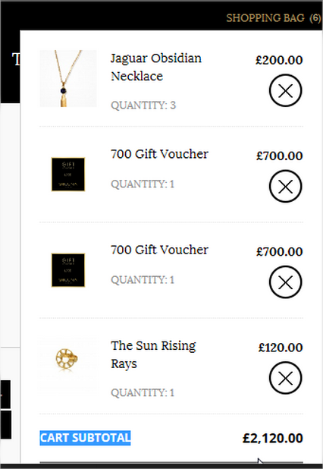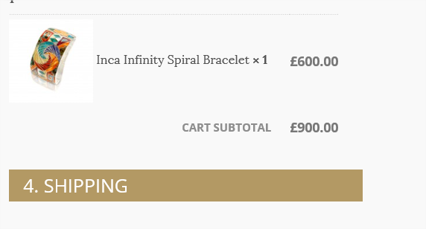

Improve layout of shopping bag
- There is a new button appearing called “APPLY GIFT CARD”. Why we are using two buttons to apply gift card discount? (Could that logic be also managed by the “UPDATE” Voucher code button?)
- Its design layout position is not optimised. If there is no way we could implement the same logic with one single button as suggested above, all these gift card field and button should be aligned to the left, below the voucher section (and not randomly as is shown in the page)
- Credit card icons are not correctly aligned to the right as it is shown in the Pay Securily button (pls fix it)
- The whole page is not mobile responsive

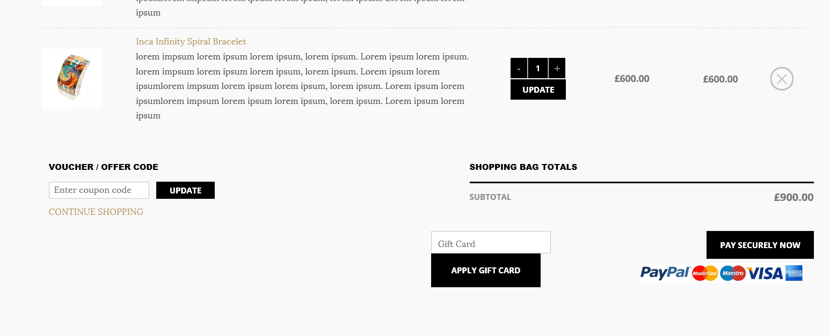

Product information is incorrect or paragraph text seem to been cut out
- How I could update the following information (data). Where I could find those option to re-edit myself or are those text and attributes been hardcoded?
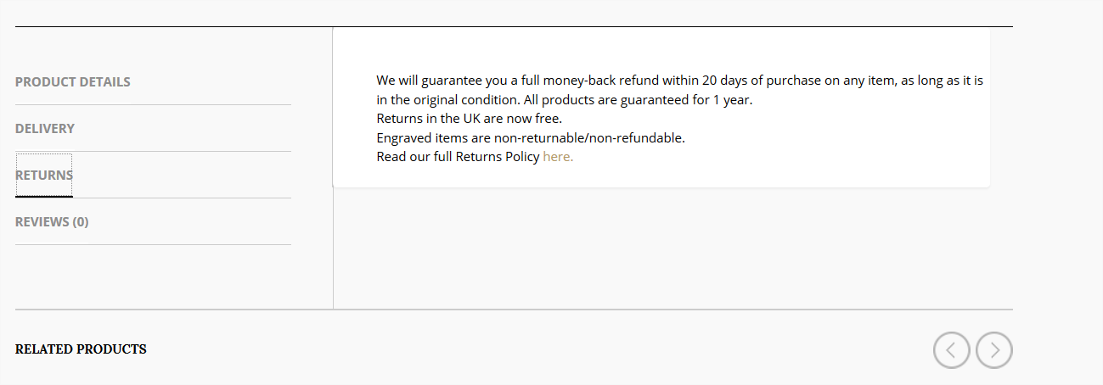
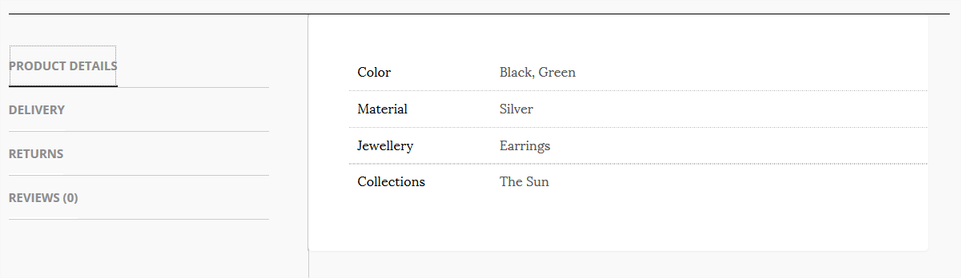
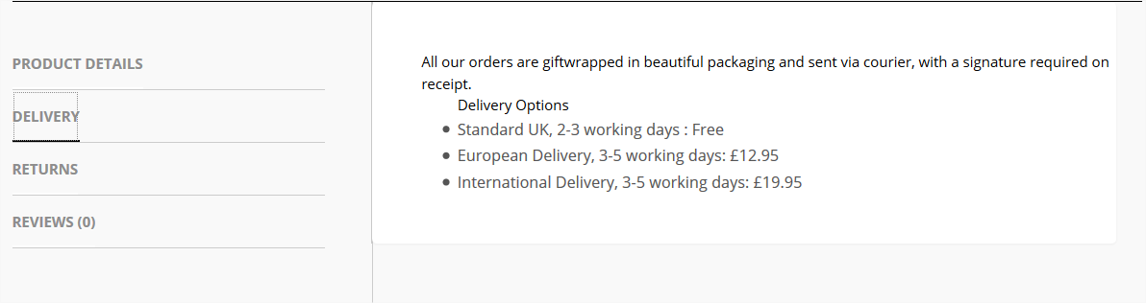

[UPDATE] Make new pages responsive and optimised for small screens
- All pages such as Shopping bag view, should display and optimised version (responsive) of the information, which they contain to have a good smartphone experience
- For instance, if the “Description” of a specific product takes too much space. It might be better just to hide the whole description or show a truncated description version
- This comments are also true for all new pages designed to support a wider and nicer shopping layout experience
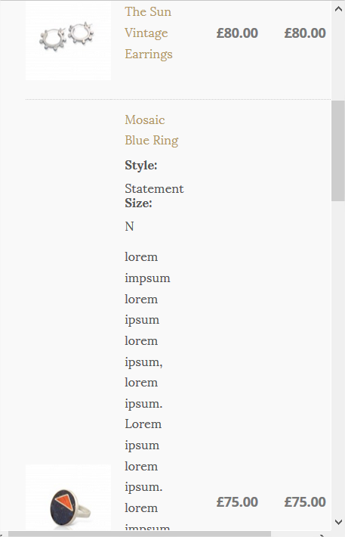

[UPDATE] Improve Checkout confirmation
- Description text too close to its left picture give more spacing
- Blue borders spaces are uneven as the description is taking way too much width space. Let’s reduce the area space for “short description” (within the two vertical red lines)
- So you could then space more even remaining columns such as Quantity Unit Price and Subtotal. That change would make it look more organised and clean layout
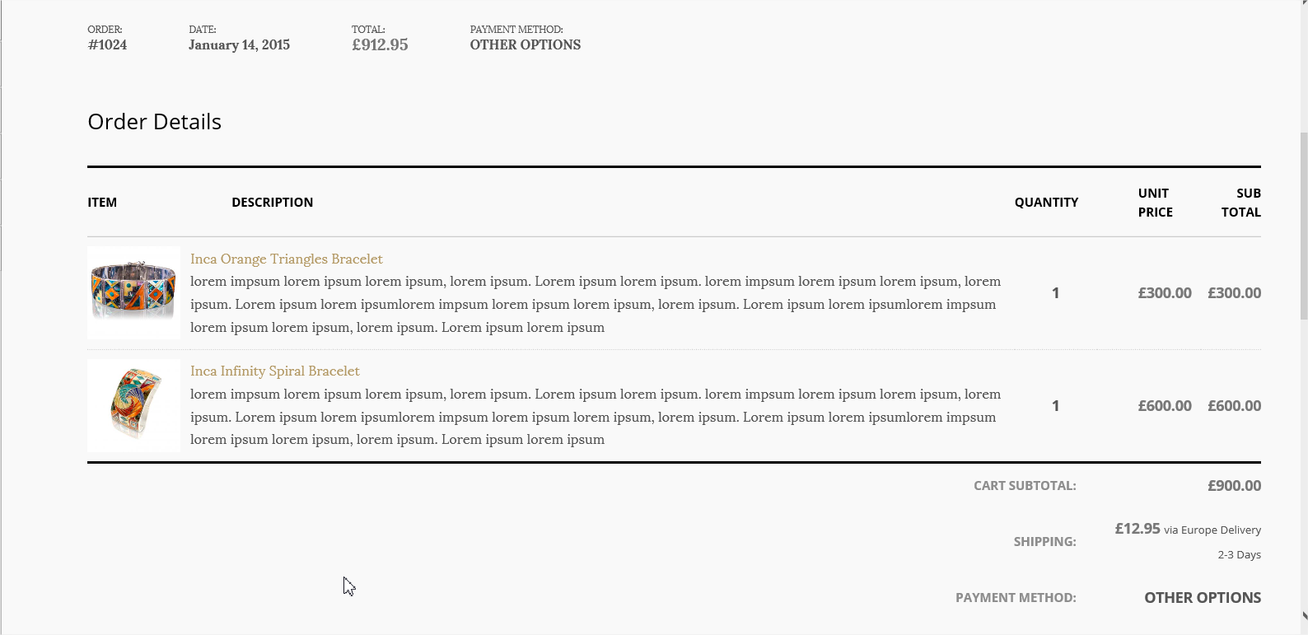
No sign out button/link is available (usability issue/inconsistency)
- I saw you implemented a SIGN OUT button on top right corner. But the question, remains is there any way that communicate and make the customer obvious that he is already signed in?
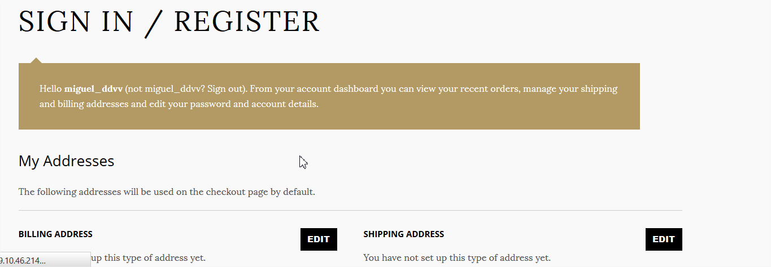

[updated] Share by email is not working (nothing happens)
- I guess the same feature is not working in other sections such as product details, blog posts, etc. Why is that? Does the customer needs to log in first or else?
- You said only if customer has his/her account email connected, the website will be able to send an email? (would this work only with MS outlook? Or will also work with webmails such as gmail, yahoo, etc)
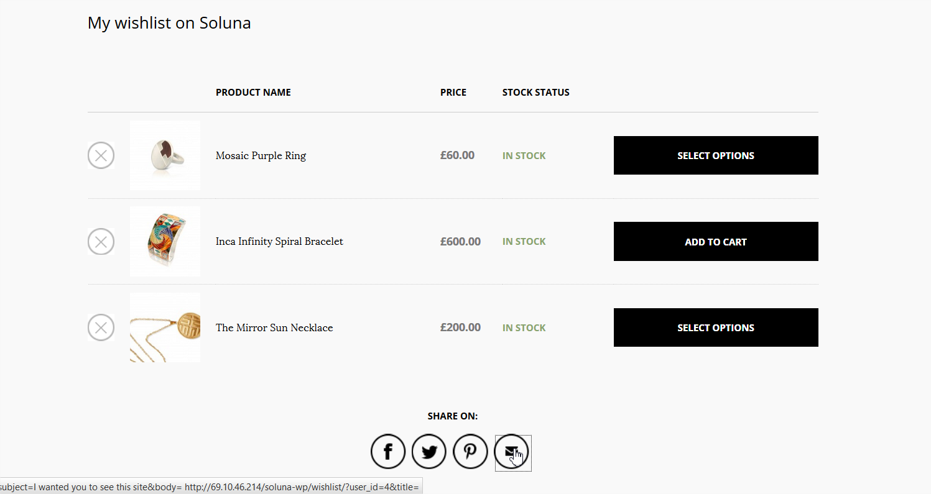

[updated] Missing elements in The Journal posts
- Just below the title of the post the category of the post and the date of publishing must be shown as described in the specs (see next couple of images below)
- “RELATED POST” is misaligned and it is not keeping the same font size as other subtitles
- Please some add some related posts to the very first blog to see the way is currently displayed in your implementation. Which needs to be exactly as shown in the spec below: Date posted, Leading Image, Short title
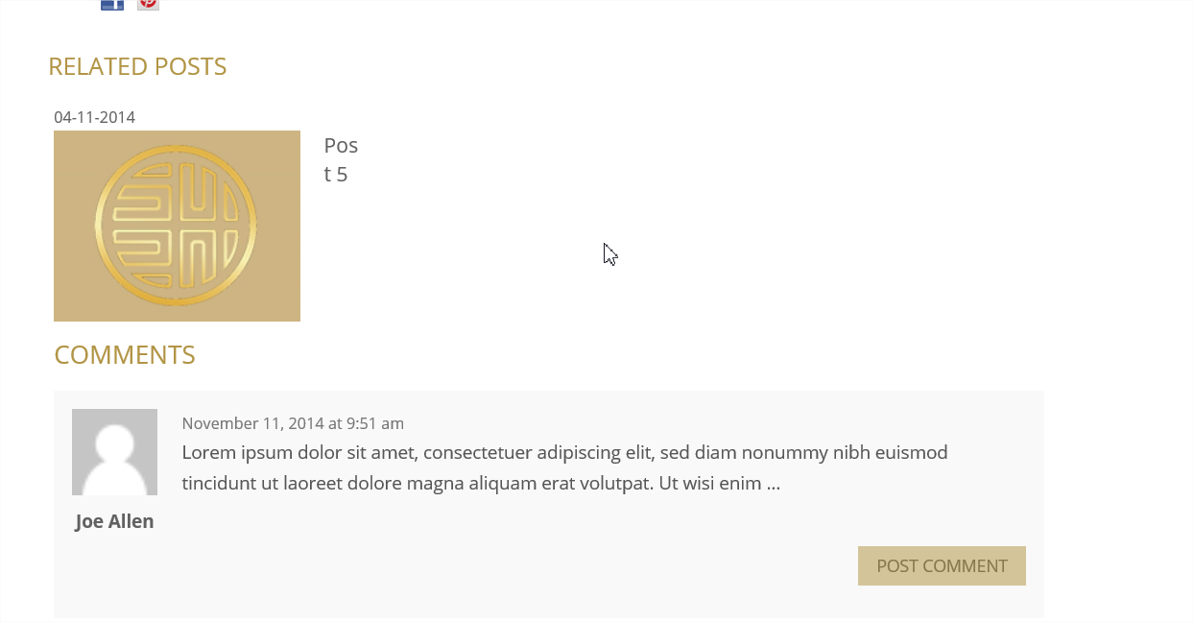

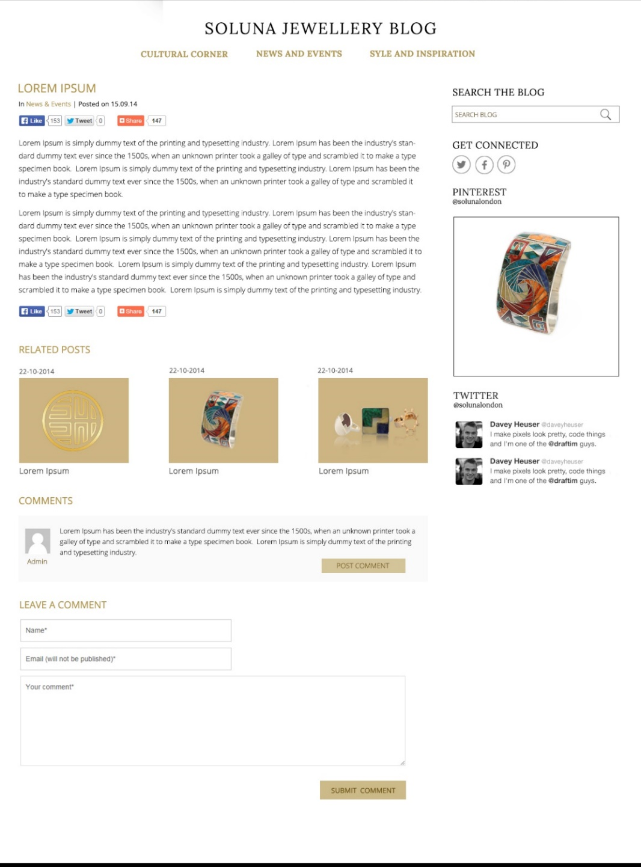

[updated ]Improve layout for smartphone screens
- There are some smartphone screen issues when displaying top banners and left text. They are not consistently aligned (sometimes the border of the images are aligned to the left of the Title below but not text itself, sometimes are centred aligned others are randomly aligned horizontally)
- This is issue is shown in all pages such as Jewellery (any kind), Collections (all collections) and Premium Services (all services). As they all have similar layout to display top banners and the text (title and body text
- It was only fixed for the Services and Jewellery top banners. Can you please do the same for the top COLLECTIONS banners (Inca Cross, the Sun, Golden Coins and Mosaic)

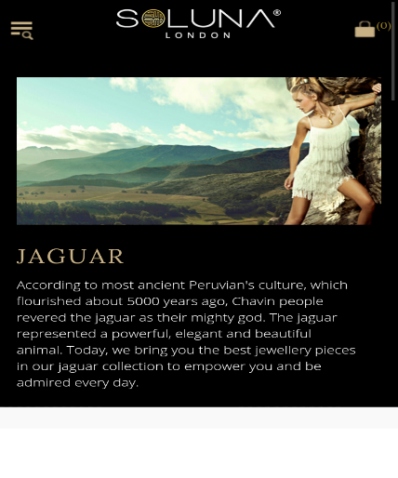

The Journal (blog post pages)
- Images in the blog post seems no to be responsive for smartphone devices (e.g. see first blog post, the pic of the girl showing one of the Jaguar pieces is not adapted to the size of the screen)
- Is that possible to control all these pictures settings in the CSS or theme template?
- Or custom any other font size, colours, links, aside text used in the posts? (if possible, which file? And which section?)

[UPDATE] Improve layout for smartphone screens
- You certainly updated the banners for the other services, jewellery, etc. However, you forgot to align the collections top banners for collections such as Golden Coins, The Sun, Inca Cross and Mosaic banners

[updated] How to manage voucher/gift card money?
- In wordpress or woo-commerce, is there any way to manage the remaining cash or credit? Or give that extra cash to customer on their next purchase. I mean someone bought a voucher of £300, but the actual jewell cost her 275. What happen with her change? (return cash or keep it)
- would you recommend to allow people the possibility to get change back if they don’t use the full amount on the gift card.
- Layout: We should use same button as shown in the voucher/offer button or improve the layout for this new button (please see above for Shopping Bag view recommendation)

[UPDATED] Pad layout Issues (Portrait and Landscape display)
- Header Portrait: make the “Soluna London logo” dimensions a bit smaller. Particularly, we need to reduce the size of other elements in the header (logo sizes, Font sizes too big, search text place holders, etc). Keep the proportions as shown in the Astley Clark iPad version (the proportions used between logo and other header elements are correct and make them look the header less crowded and elegant)
- Landscape Portrait:
- Contact: is there any way to improve current display for iPad portrait view? (the information looks uneven and somewhat messy). One solution will be to reduce the size of the fonts on the left image (particularly the one with the offices addresses)

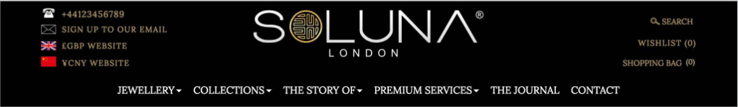
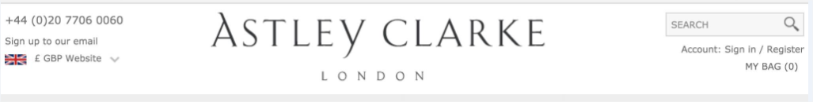

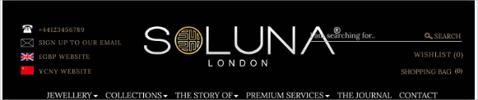
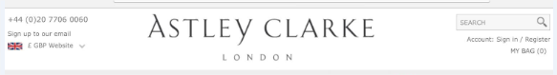

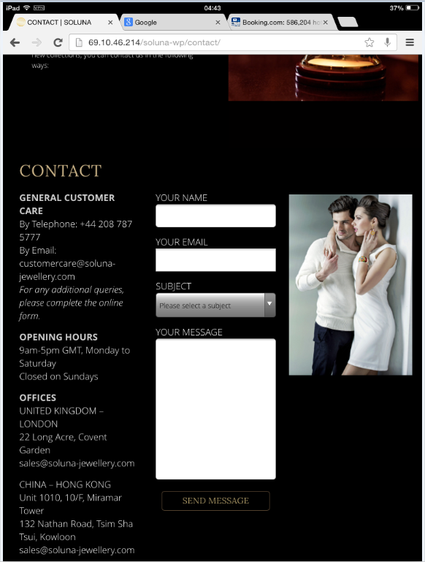

Price Filter is not working with Variable products
- After applying the filter of narrower version of prices, still displaying the images of more expensive items. (so at the end, for the end customer looks like its filter options didn’t work). Why?
- The price was filter between: 120-416 (and sometime show items that cost more than the specified range)
- Please suggest what we could do here?
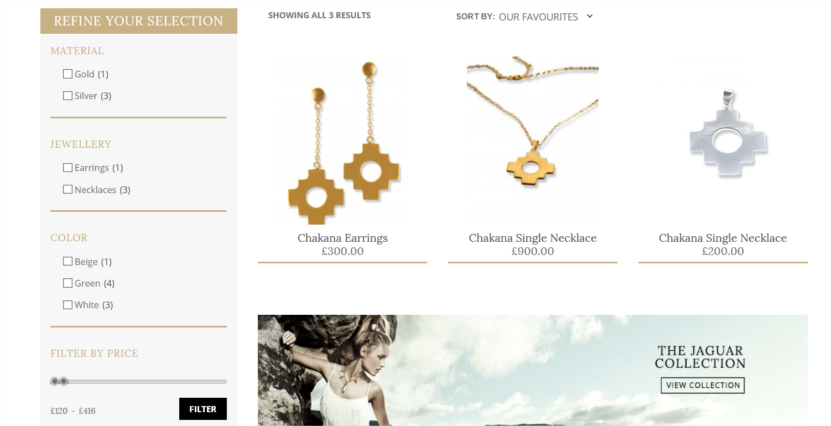

Improve Gift Cards Layout
- Make them responsive for mobile screens, adjust image size to better fit for small screens.
- Improve the width sizes of the field containers as well as the descriptive text
  - To (first name)
  - Sent To (email)
- Replace generic text "all fields are optional" by this: “Your Gift Card will be emailed directly to your recipient, along with a personal message of your choice.”
- After migration, some gift cards are missing as shown in the picture

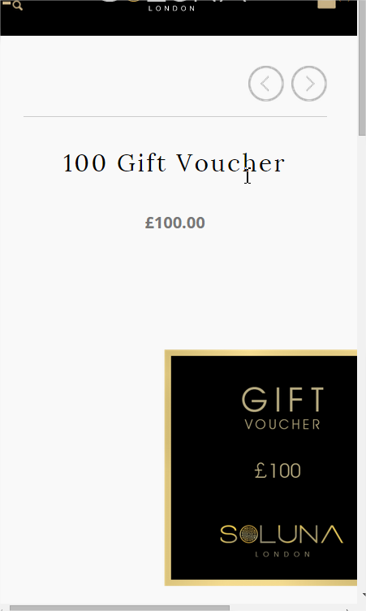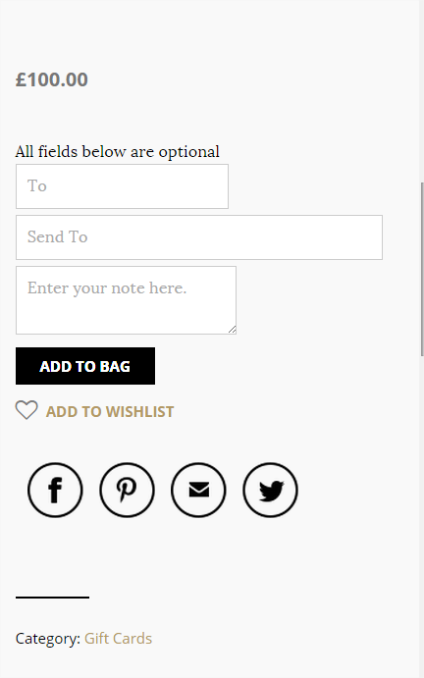
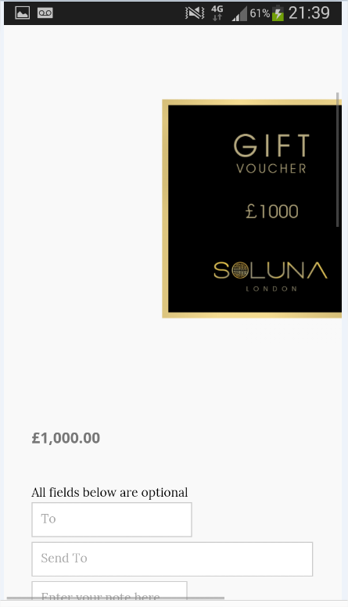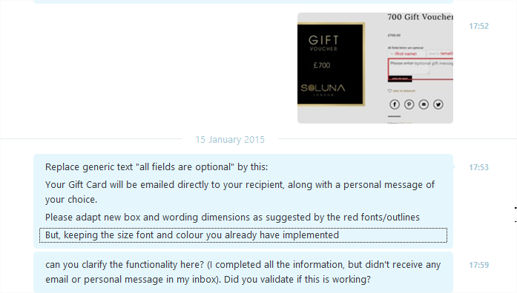

Remove/disable option to download any image from website
- No single product image, banners, icons, etc should be allow for users to download to their local drives

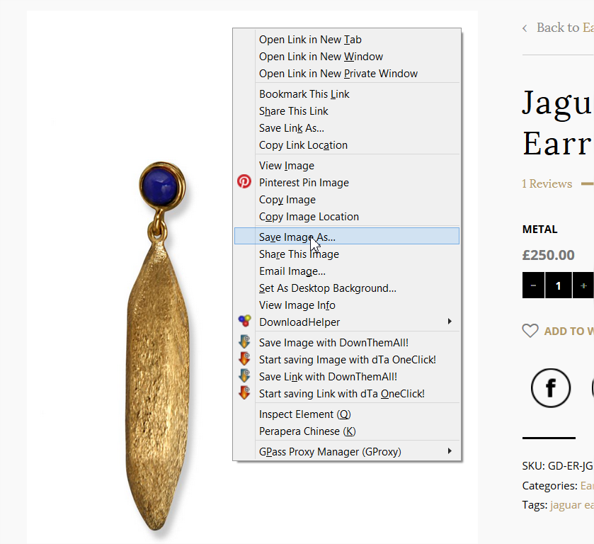

Remove/hide the option that shows that we are using a paid “THEME”
- Is that possible to users not to know which theme we used for our site implementation

New Shopping and Checkout Layout issues
- In the web screen, too much separation of the columns “Quantity and unit Price” vs “Subtotal”. Move them both more to the right to get an even spacing between those 3 columns
- In the smartphone screen, UNIT Prices are too close to the picture next to it, please give some spacing to have an empty space between them (one solution might be to move the whole Unit price column a few pixels to the right and also think of reducing the font sizes of prices next to them for small screens)
- Sometimes we see some inner text in the field text to be cropped (e.g. see below wording Gift card, we can barely see fully and correctly displayed or data filled in the checkout process)
- Reduce the font size of the price and make the product name and the price to be aligned at the top. Of course, the product name can be longer, in which case it could take two or three rows. However, price tag and product name must be aligned (when displaying in small screens)

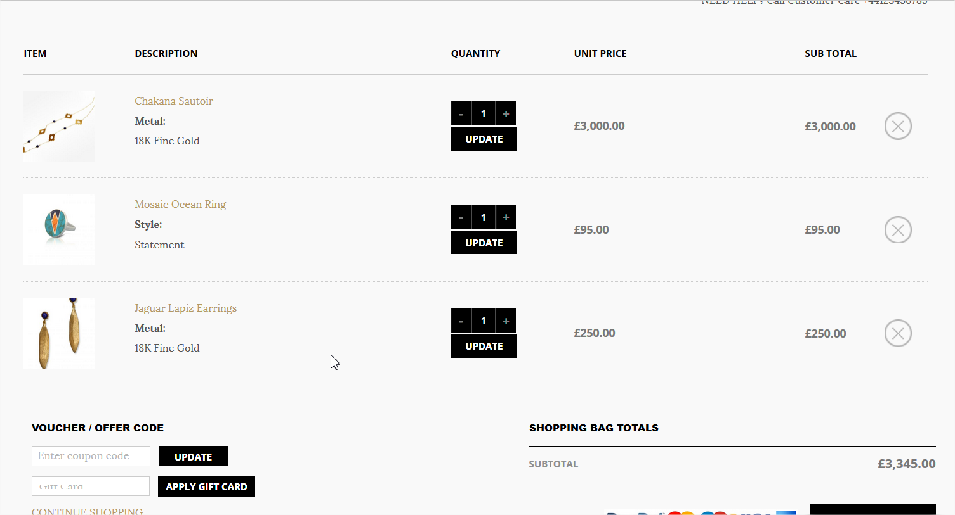
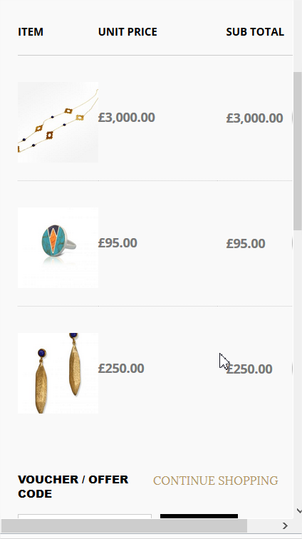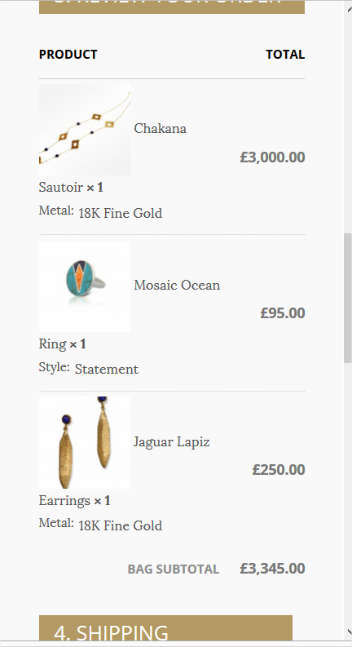
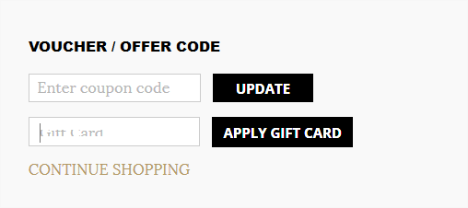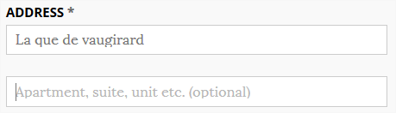

New Checkout confirmation Page
- Move columns “Quantity and Unit Price” to the right. Closer to Subtotal unnecessary empty spaces. It just make them look amateur the site and vert clean designed
- In the mobile screen, make the ORDER, DATE (one row) and TOTAL and PAYMENT METHOD (another row), with some empty space separation beween them. Right now the information look disorganised
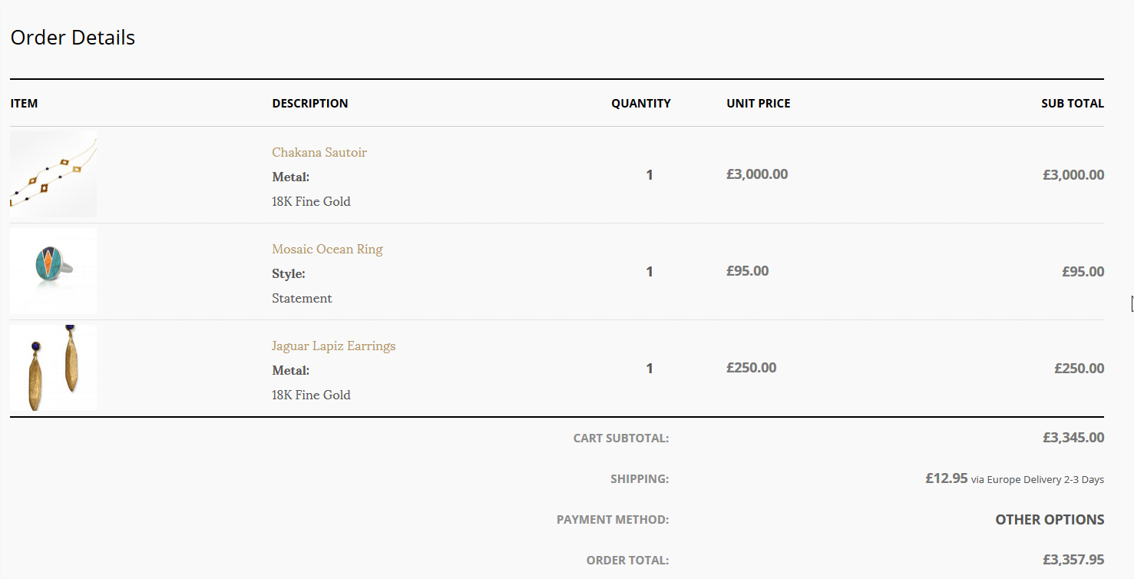

iPad Air 2 display issues of Labels in butttons
- This appears in the HP and all services pages, please fix it accordingly
- In the HP section Free UK Delivery, Please make the button label text “View collections” show in one row
- In each of the service pages appear in the golden section, please make the “Read More Here” show in one row
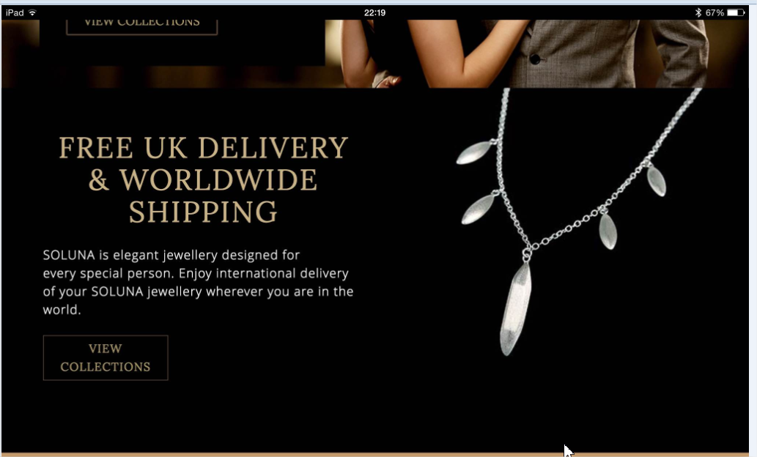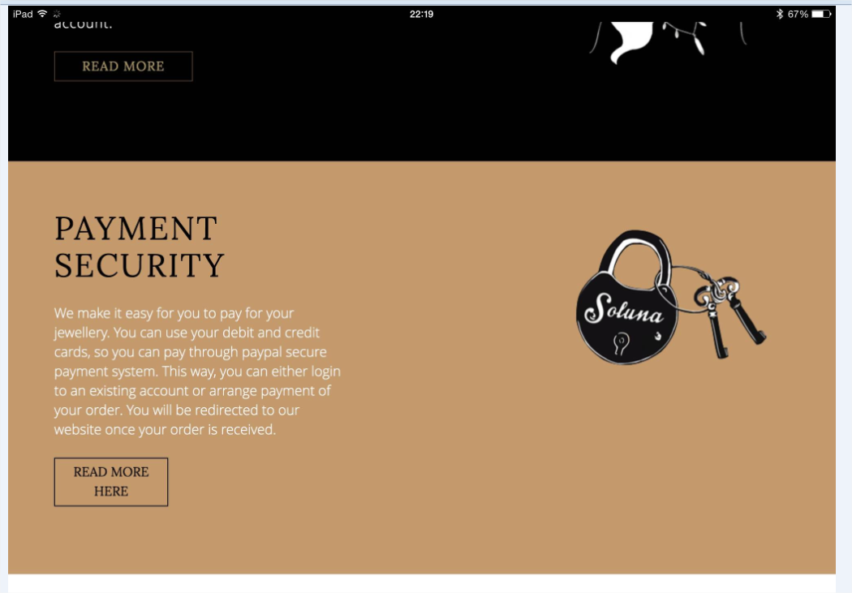
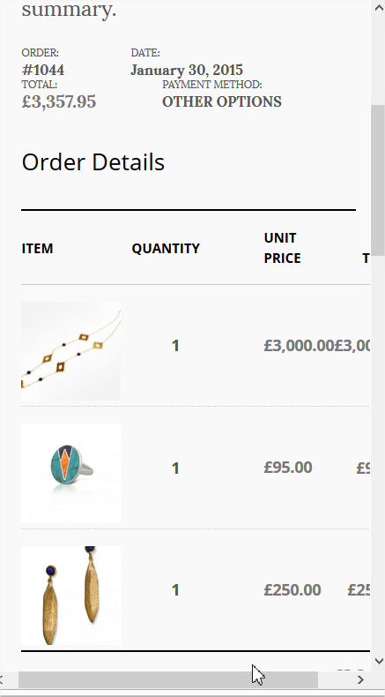

New Product details issues
- The page and images and site content are not fully responsive.
- In the mobile devices show two different prices at the same time. This will confuse customers. Just one price is shown (it could be repeated if one is show at the top and one at the bottom – but the value must be the same)
- Improve some list box display, which are cut out and don’t display full name of the options
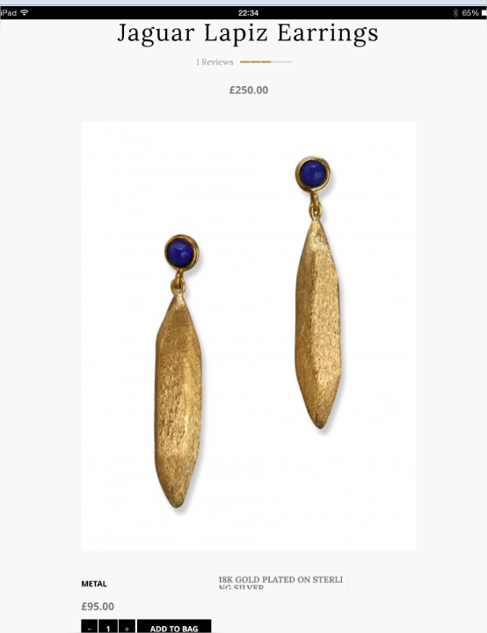

Make use same fonts and size.
- In the Story section, the fonts used in the black section seems bigger than the ones use in the golden section. If different, please make them look exactly the same size as the copy in the golden section
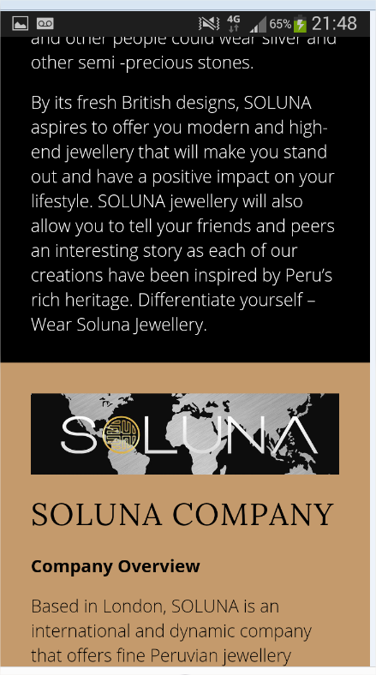

Blogs are not fully resposive
- Some picture are too big to fit in the smaller screeen.
- Also adapt or maximise the web elements to fit the smaller screen
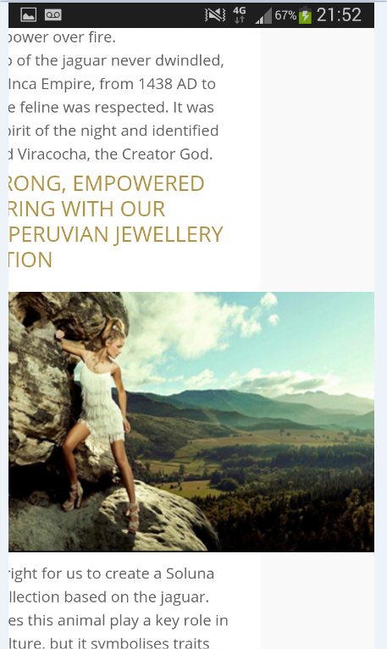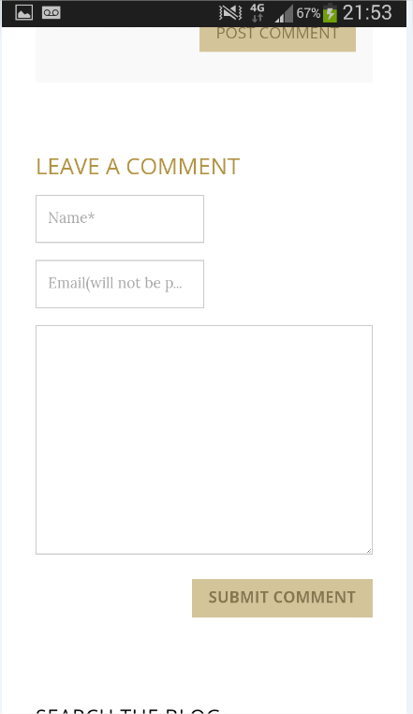

Use Soluna Branding colours wheen sending emails
- Change the blue colour background to Soluna Golden background
- At the bottom of the email, replace blue font to match Soluna golden font
- Also, ALWAYS use email communications from Soluna Email addresses when communicating
