

USER MANUAL

CREATED BY PENTAGON SOLUTIONS
www.pentaus.net

INDEX

1. Login 3
2. Pages 4
2.1. Editing a Page
2.2. Add New Page
3. Restaurant Gallery on Gallery Page of Tenleytown 6
3.1. Add New Gallery
4. Critical Acclaims in South West Water Front 8
4.1. Add New Acclaim
5. Home Background Slider 9
6. Innerpage Background Slider 10
7. Southwest Menu 18
7.1. Add New Southwest Menu Item
7.2. Editing Food Category
7.3. Re-Order Southwest Menu Items
8. Tenleytown Menu 20
8.1. Add New Tenleytown Menu Item

9. South West Water Front 18
9.1. To Re-Order the pages of South West Water Front
10. Tenley Town 20
11. Customer Reviews 20
12. MailPoet 21
12.1. Newsletters
12.2. Subscribers
13. My Options 23

1. Login
In order to make any modifications to your site, you need to log in to the Administration. Enter. http://www.masalaartdc.com/wp-admin/ in the URL. You will find the login page at this URL

Login Details
USER NAME : admin@art
PASSWORD : 4441masalart

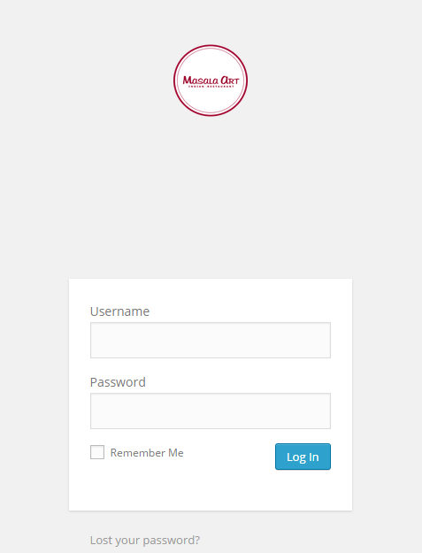

After logging in to your site, it will take you to the back end of your website i.e. Dashboard.

2. Pages
On clicking the Pages menu option you'll be shown a list of Pages that your site contains. Among the information displayed is the Page title, the Author and the Date published. The Pages screen will look similar to the screen below.

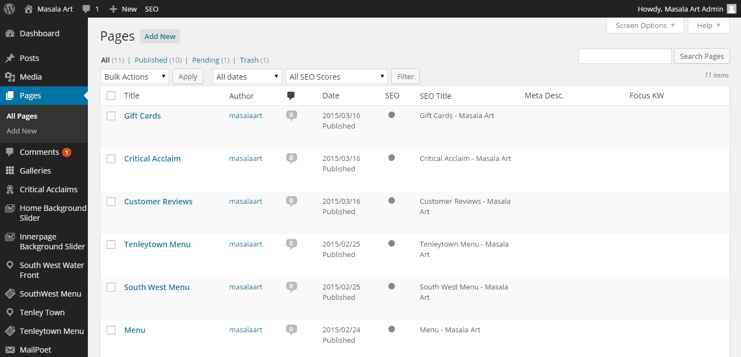

At the top of the page you can view how many Pages in total you have on your site and how many are published.

2.1 Editing a Page
While Editing a Page, there are certain things to be kept in mind.

1. Edit the Page Name.
2. Edit the content in the Editor.
3. If you want to change the Parent page under which this page must appear as a Sub-Page, select the desired Parent from the Parent dropdown.
4. If you want the Page to be a standalone Page, select the desired template from the Template dropdown.
5. Once the content is added, click Publish to view the changes in your site.

2.2. Add New Page
To add a new Page to your website, hover your cursor over the Pages menu option in the left hand navigation menu and in the fly-out menu, select “Add New” option. You will be presented with a page similar to the image below.

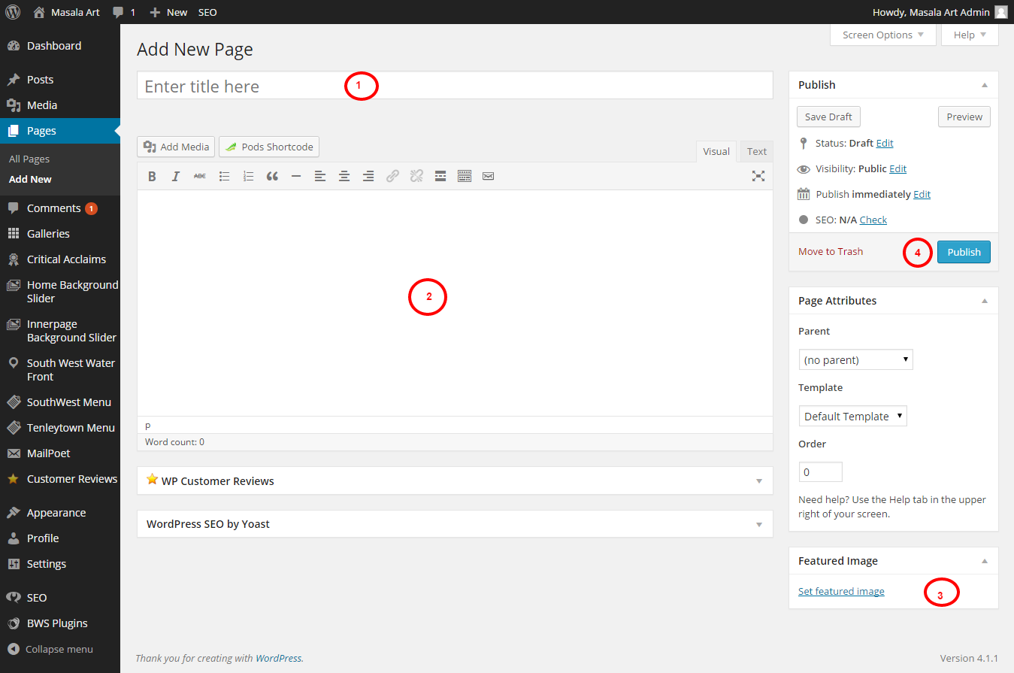

1.For editing title of the page.
2. You can add the content in the Editor, and style your page using Visual or Text editor by switching between Visual or Text.
3.For uploading image, just click on “set featured image” link and select appropriate image from your system files.
4.Once the content is added, click on “Publish” button for publish the post or save as Draft.

3. Restaurant Gallery on Gallery Page of Tenleytown

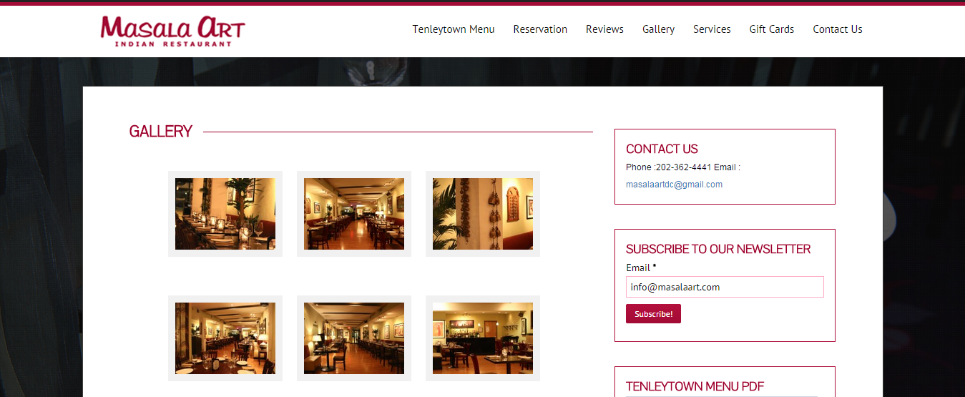

3.1. Add New Gallery
To add a new gallery to “Galley” page, click on the ‘Galleries’ menu from the dashboard left navigation and in the fly-out menu, click the ‘Add a Gallery ‘ menu. You will be presented with a page similar to the image below.

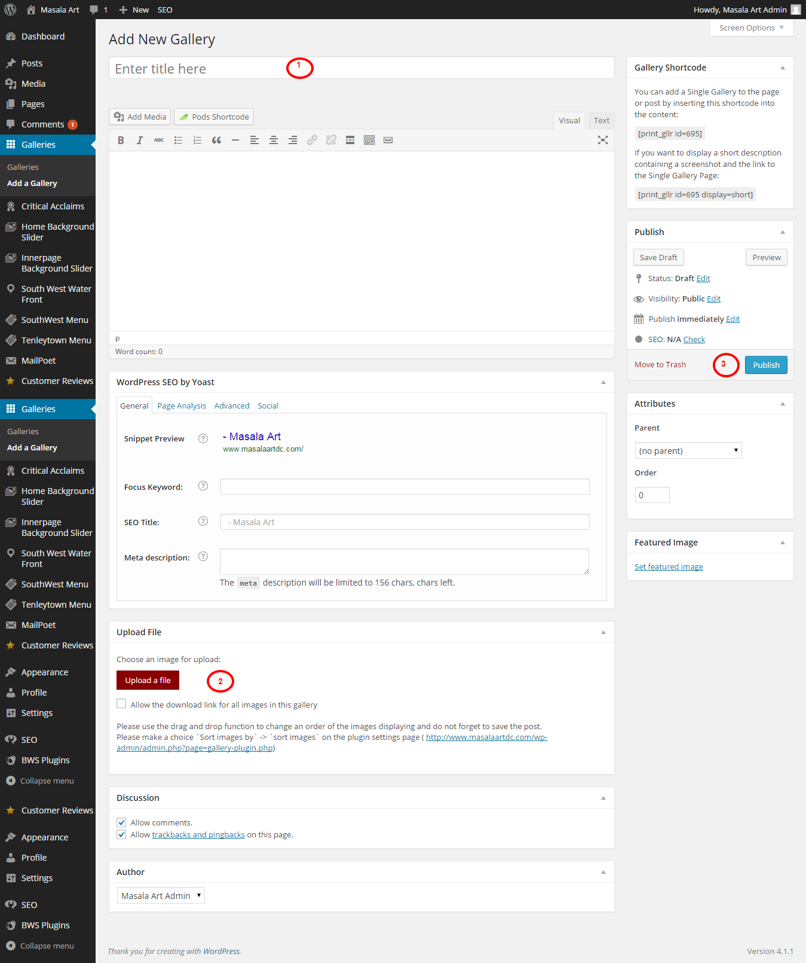
1.For editing title of the gallery.
2. For uploading image, just click on “Upload a file” button and select appropriate image from your system files.
3. Once the images are added, click on “Publish” button for publish the post or save as Draft

4. Critical Acclaims in South West Water Front

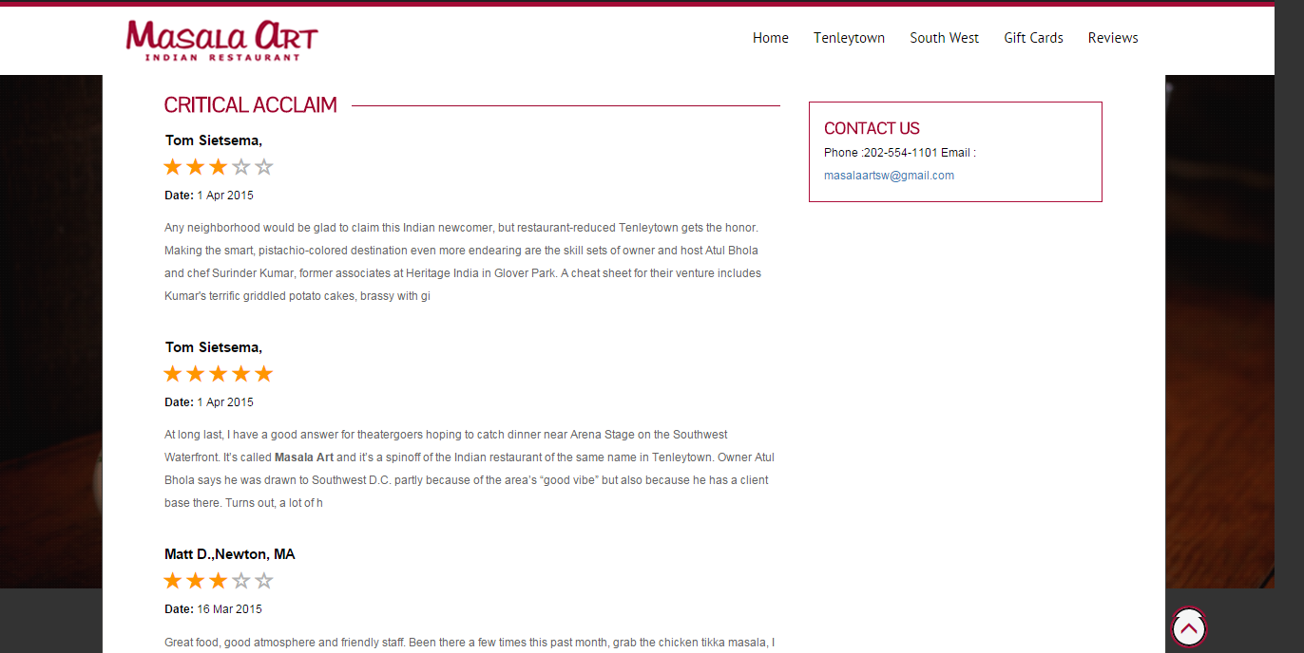

4.1. Add New Acclaim

To add a new Acclaim to “Reviews” page in the South West Water Front, click the ‘Add New’ menu in the fly-out menu on the ‘Critical Acclaims’ menu from the dashboard left navigation. You will be presented with a page similar to the image below.

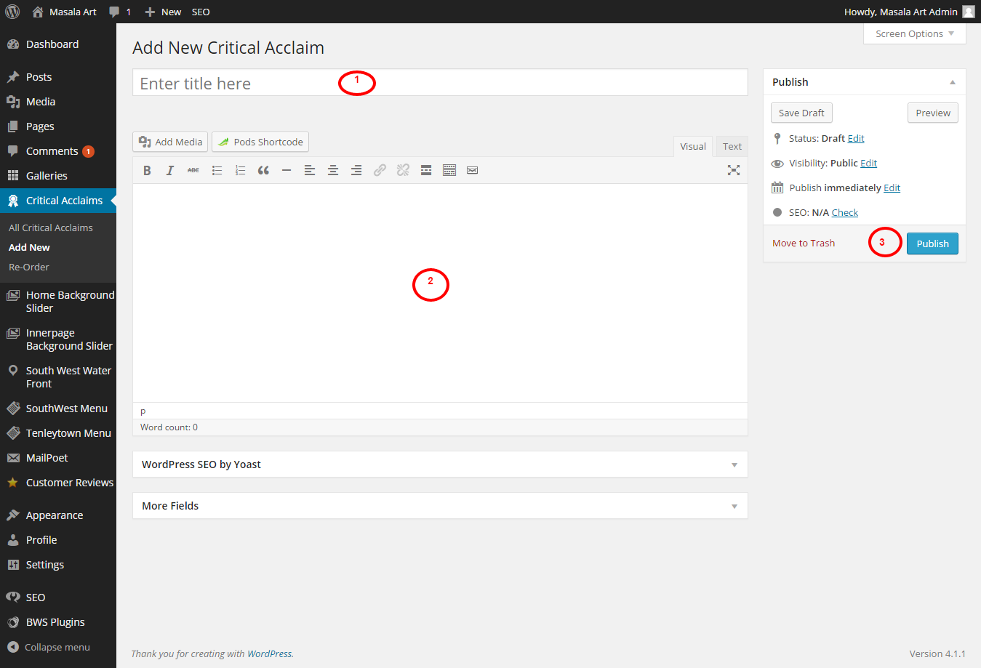

1. For editing name of the Critical Acclaim.
2. You can add the description about the Critical Acclaim in the Editor, and style your page using Visual or Text editor by switching between Visual or Text.
3. Once the content is added, click on “Publish” button to publish Acclaim.

5. Home Background Slider
To add a new Home Background Slider to “Home” page, click on the ‘Home Background Slider’ menu from the dashboard left navigation and in the fly-out menu, click the ‘Add New ‘ menu. You will be presented with a page similar to the image below.

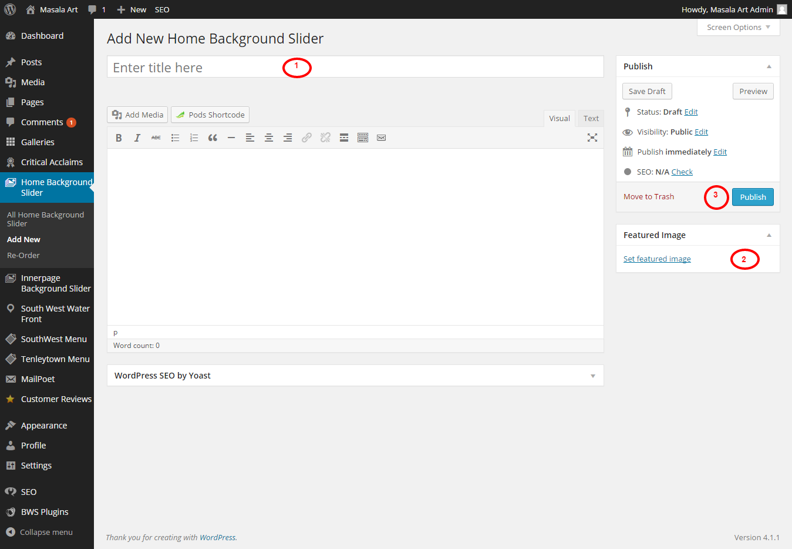

1. For editing name of the Home Background Slider.
2. For uploading image, just click on “Set featured image” link and select appropriate image.
3. Once the content is added, click on “Publish” button for publish the post or save as Draft.

6. Innerpage Background Slider
To add a new Innerpage Background Slider, click on the ‘Innerpage Background Slider’ menu from the dashboard left navigation and in the fly-out menu, click the ‘Add New ‘ menu. You will be presented with a page similar to the image below.

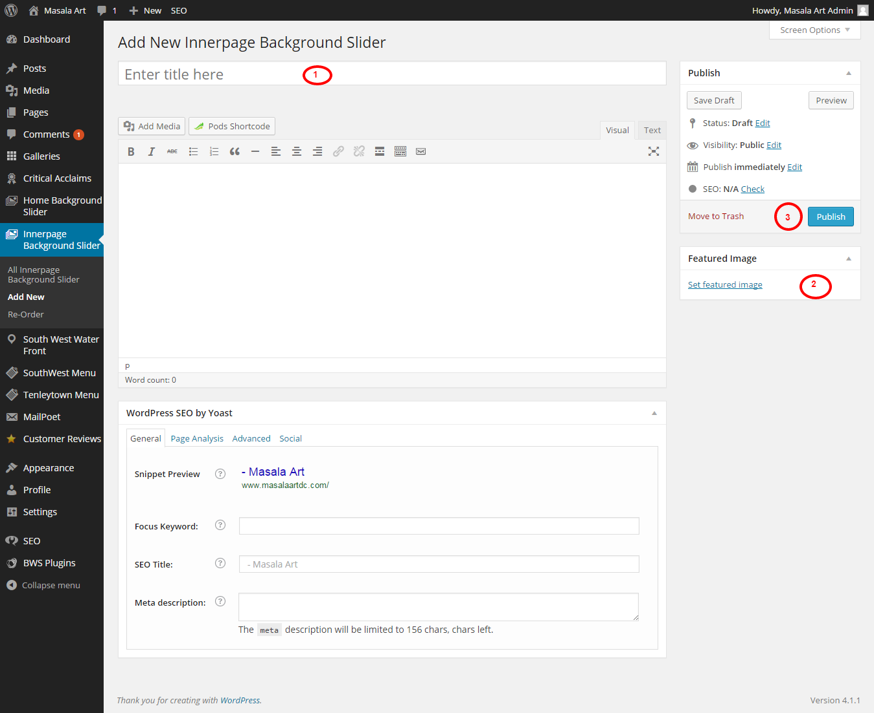

1. For editing name of the Innerpage Background Slider.
2. For uploading image, just click on “Set featured image” link and select appropriate image.
3. Once the content is added, click on “Publish” button for publish the post or save as Draft.

7. Southwest Menu

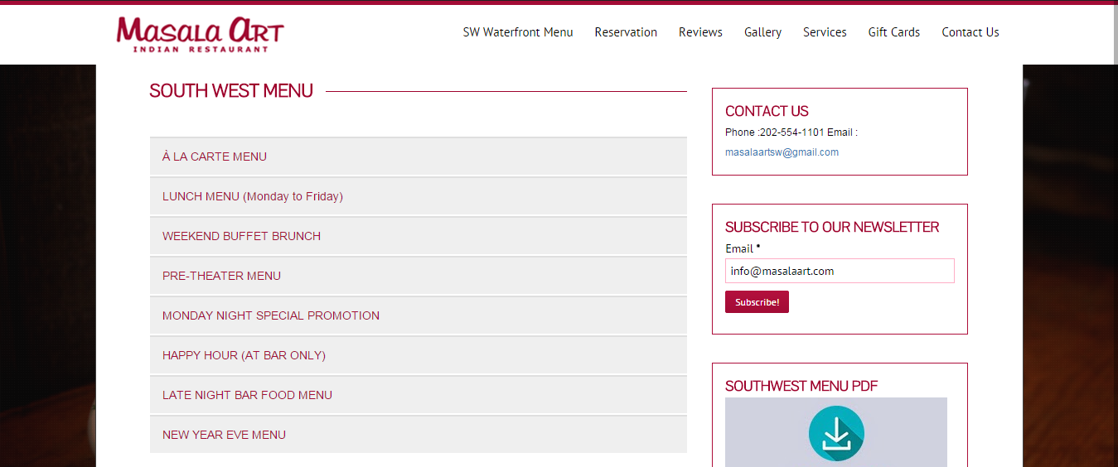

7.1. Add New Southwest Menu Item

To add a new Southwest Menu Item to “Southwest Menu” page, click on the ‘Add New’ menu in the fly-out menu from the dashboard left navigation.
You will be presented with a page similar to the image below.

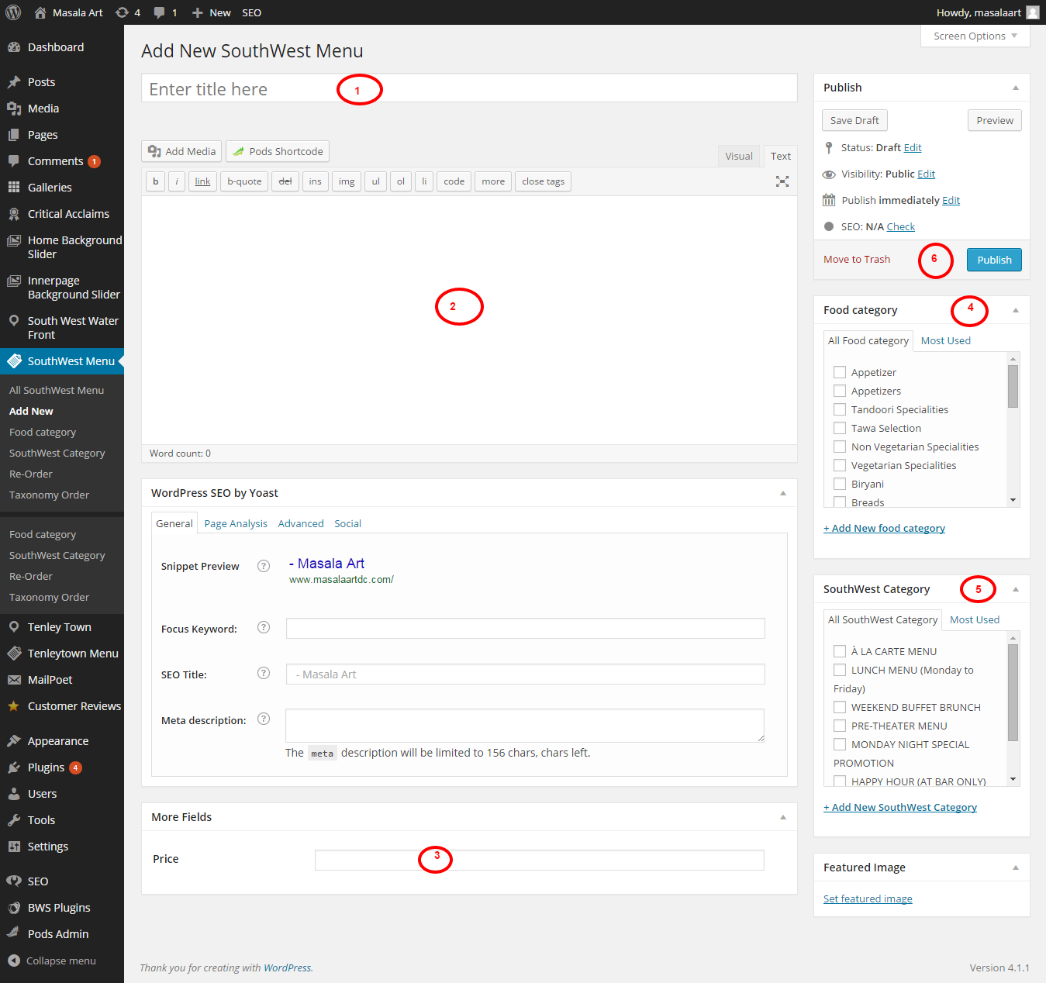

1.To add name of the food item.
2.To add a description about the food item.
3. Enter the price for the food item.
4. Select or Add a food category for the food item.
5. Select or Add a southwest category for the food item.
6. Click on ‘Publish’ to publish the food item page.

7.2. Editing Food Category

To edit the food category click on the Food Category menu in the fly-out menu of Southwest Menu, from the dashboard left navigation. Then click on
edit link showed just below each food category in the edit food category page. Then you will be presented with a page similar to the image below.

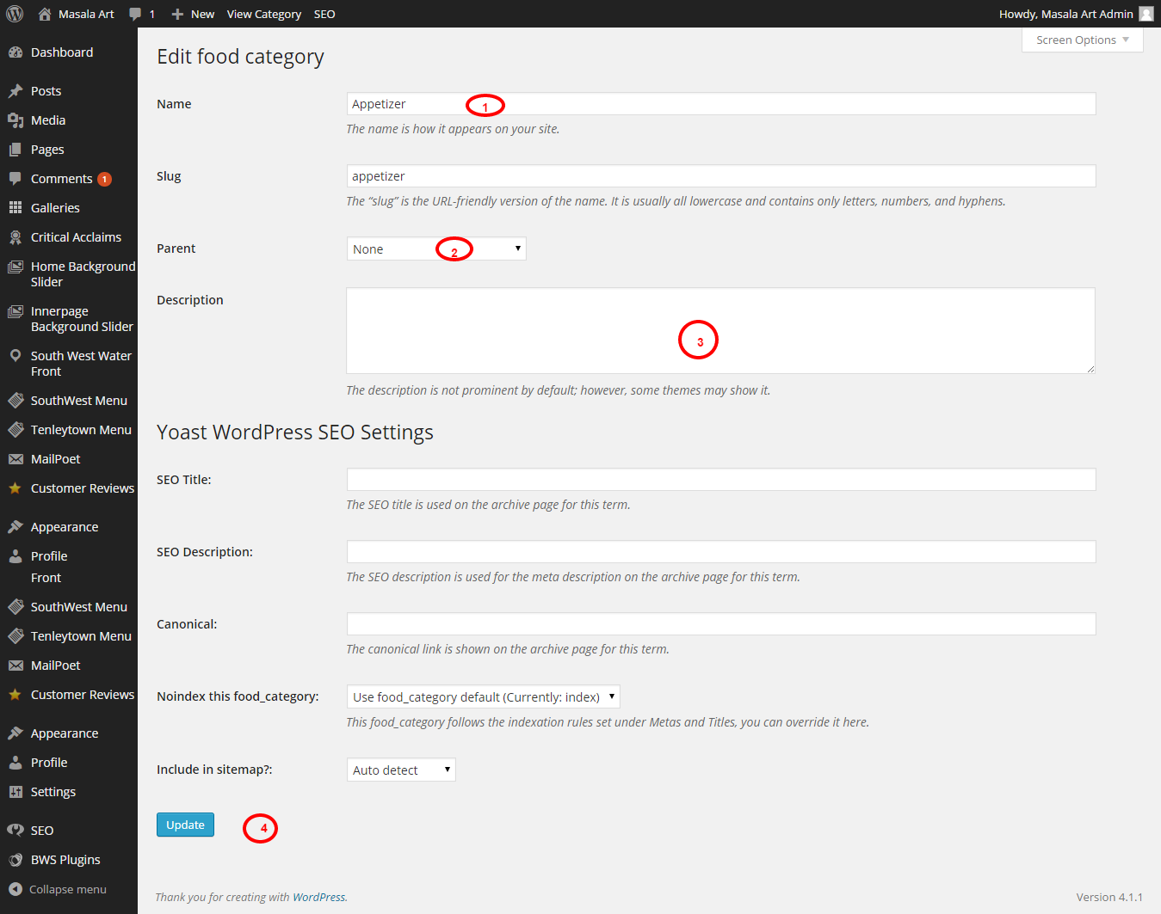

1. For editing name of the Food Category.
2. You can select a parent if required.
3.You can add description for the category.
4. Once the content is added, click on “Update” button.
Similar way you can Edit Southwest category menu in the fly-out menu of Southwest Menu.

7.3. Re-Order Southwest Menu Items

To Re-Order the Southwest Menu Items click on the Re-Order menu in the fly-out menu under Southwest Menu, from the dashboard left navigation. You will be presented with a Re-Order page as shown below.

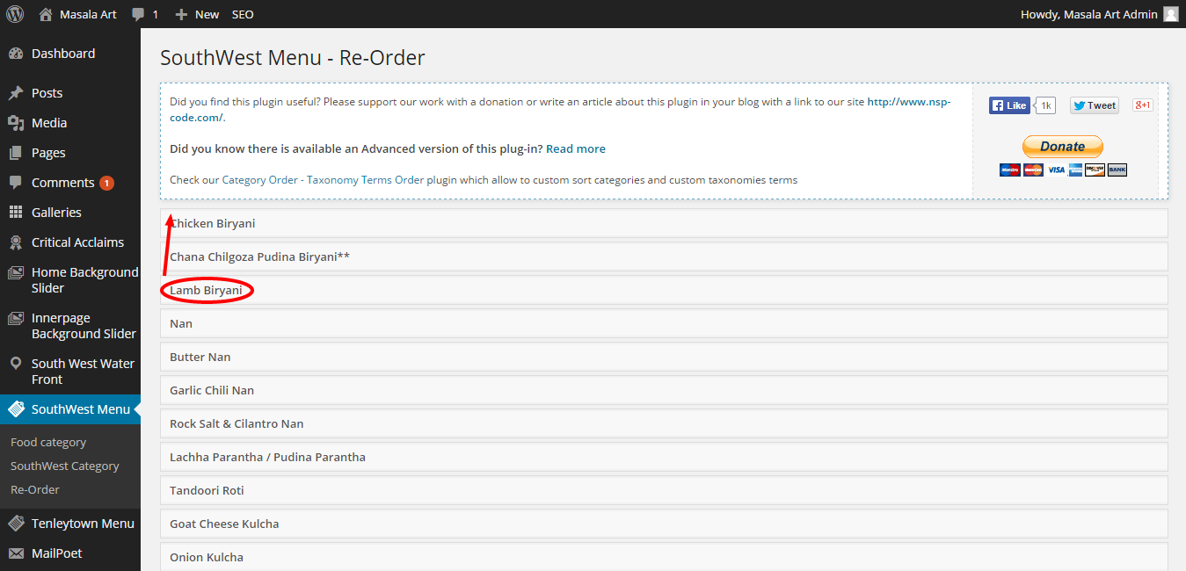

You can rearrange the order of the menu items, by clicking and dragging them to the appropriate position you want. Here in the above image, the food item Lamb Biriyani is placed in the 3rd position. If you want to put it in the first position, click on the item then drag it to the first position as shown in the image above. After dragging item to the appropriate position, click on update button to save the rearranged order as show in the image below.

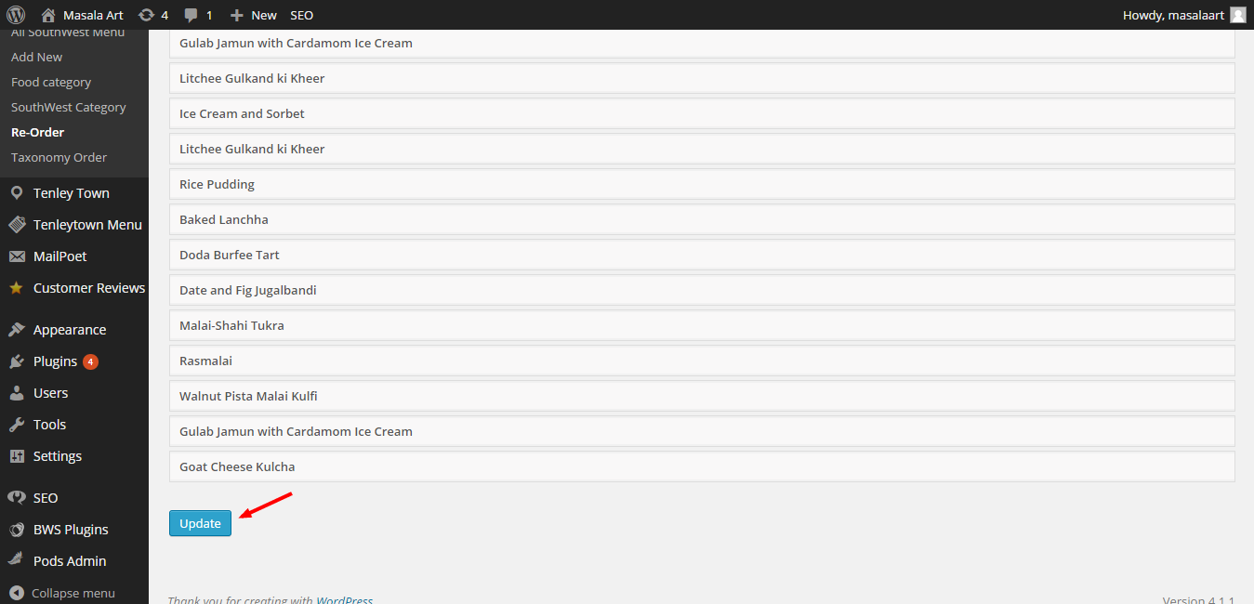

Similar way you can reorder the Taxonomy Order under Southwest Menu.

8. Tenleytown Menu

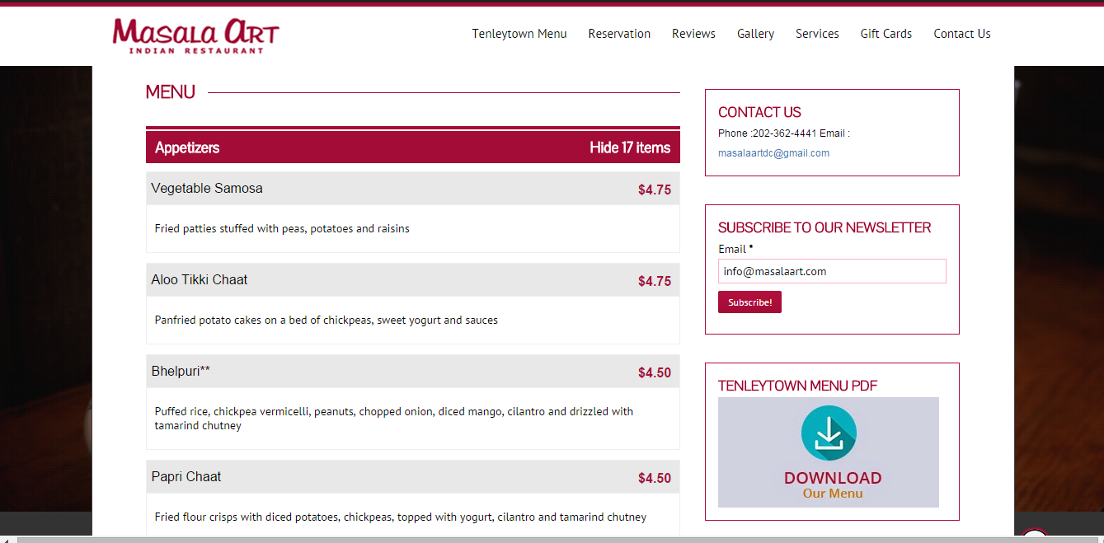

8.1. Add New Tenleytown Menu Item

To add a new Tenleytown Menu Item to “Tenleytown Menu” page, click on the ‘Add New’ menu in the fly-out menu from the dashboard left navigation. You will be presented with a page similar to the image below.

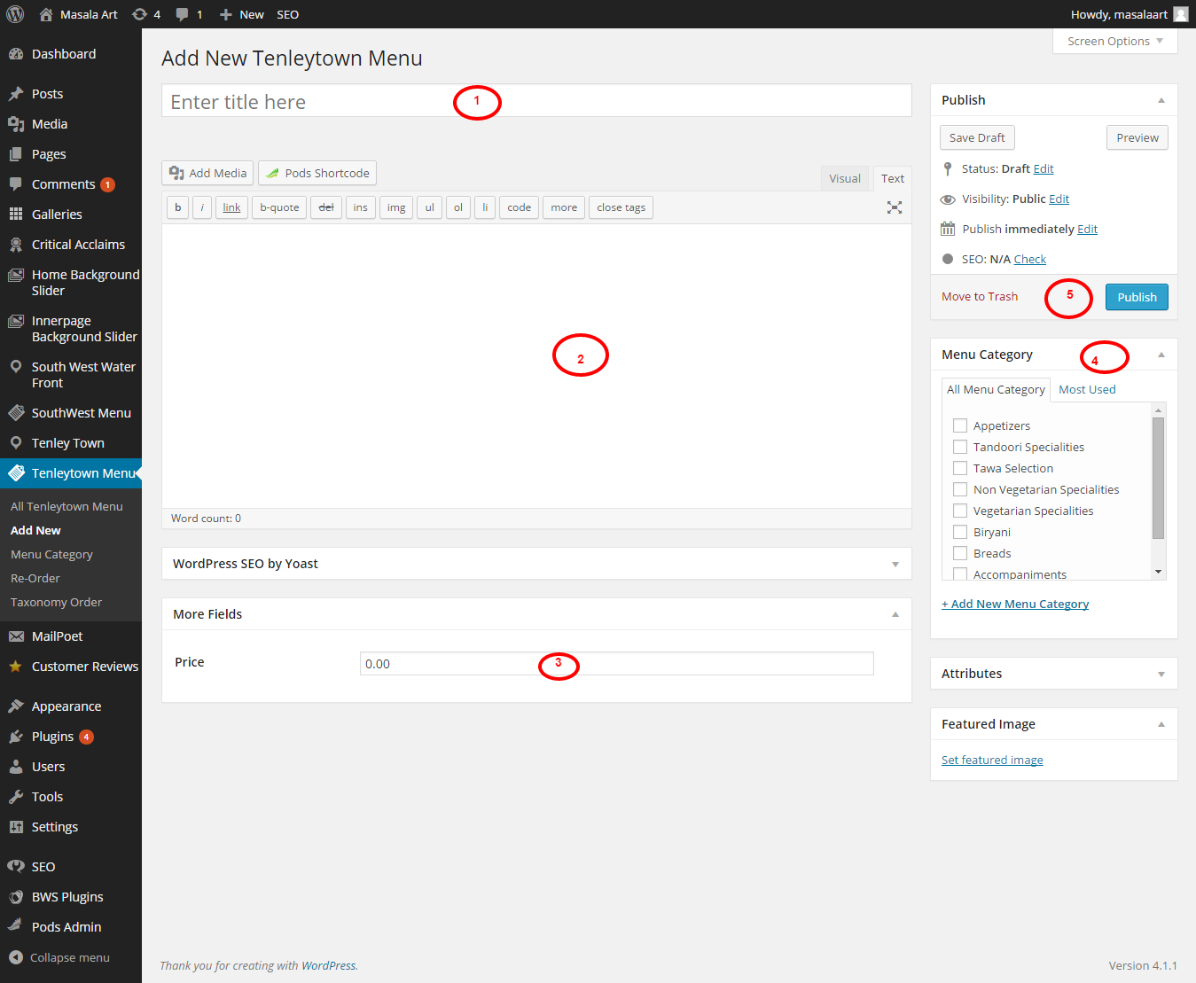
1.To add name of the food item.
2.To add a description about the food item.
3. Enter the price for the food item.
4. Select or Add a Menu Category for the food item.
5. Click on ‘Publish’ to publish the food item page.
You can edit the Order & Taxonomy order of the items in Tenleytown menu similar way that of Southwest Menu.

9. South West Water Front

To add a new South West Water Front page click on the ‘Add New’ menu in the fly-out menu under South West Water Front, from the dashboard left navigation. You will be presented with a page similar to the image below.

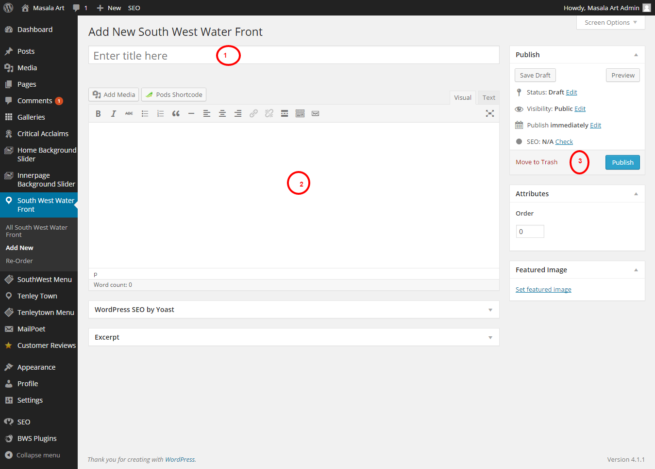

1.To edit name of the page.
2.To add a description about the page.
3. Click on ‘Publish’ to publish the page.

9.1. To Re-Order the pages of South West Water Front

To Re-Order the pages of South West Water Front, click on the Re-Order menu, in the fly-out menu under South West Water Front, from the dashboard left navigation. You will be presented with a page similar to the image below.

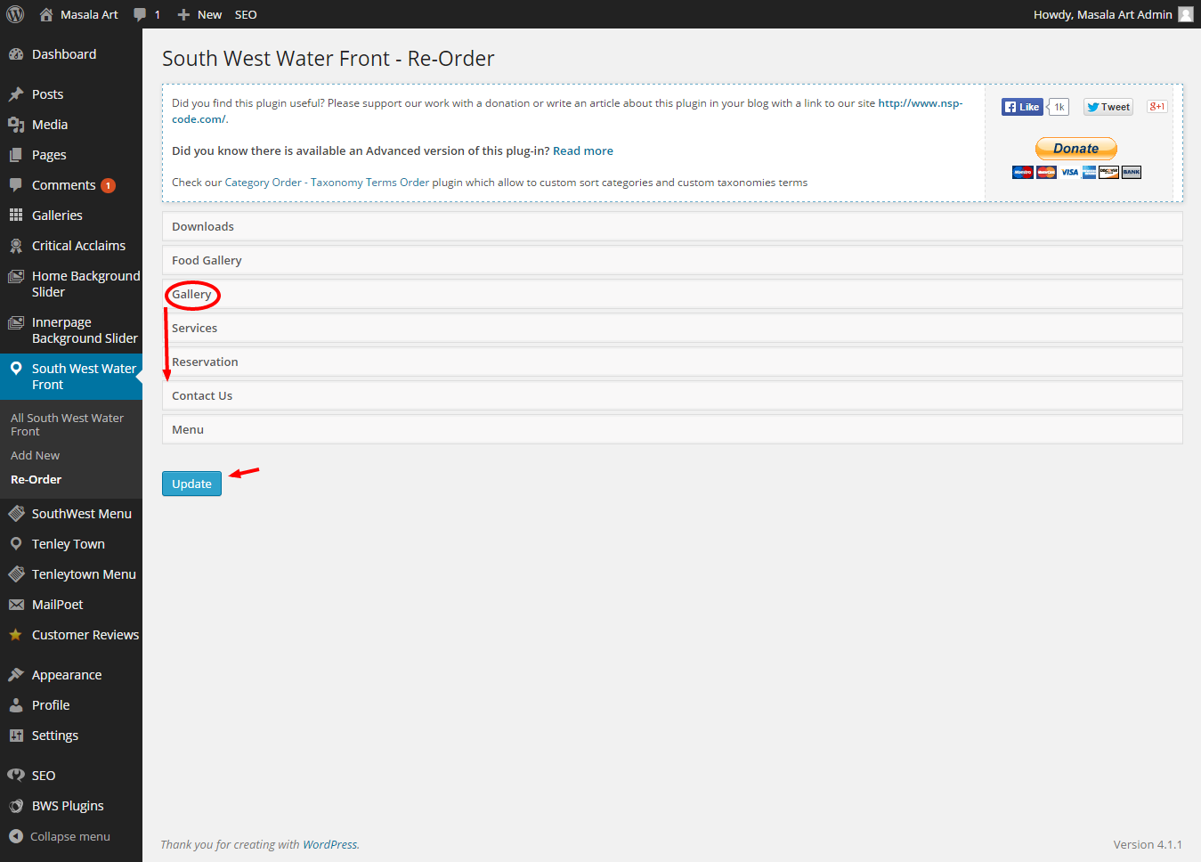

You can rearrange the order of the pages, by clicking and dragging them to the appropriate position you want. Here in the above image, the page Gallery is placed in the 3rd position. If you want to put it in the fifth position for example, click on the page then drag it to the fifth position as shown in the image above. After dragging page to the appropriate position, click on update button to save the rearranged order as show in the image above.

10. Tenley Town
To add a new Tenley Town page click on the ‘Add New’ menu in the fly-out menu under Tenley Town, from the dashboard left navigation. You will be presented with a page similar to the image below.

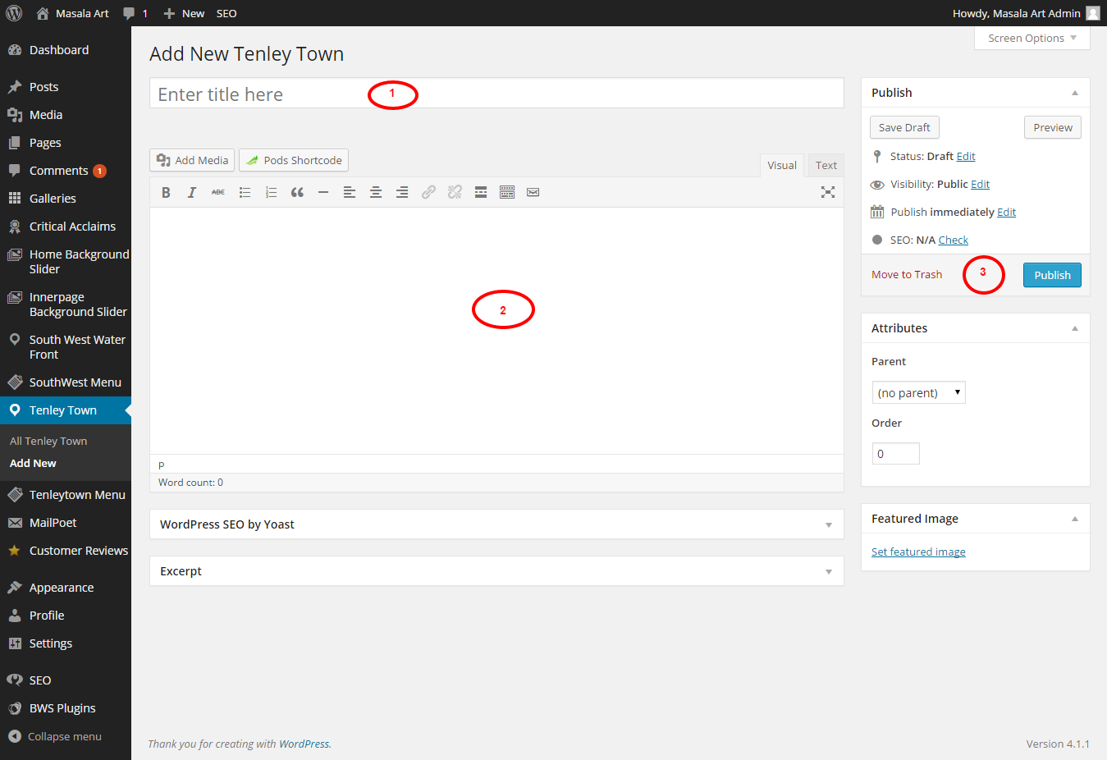

1.To edit name of the page.
2.To add a description about the page.
3. Click on ‘Publish’ to publish the page.
You can rearrange the order of the pages similar to South West Water Front.

11. Customer Reviews
You can approve or delete Customer Reviews through dashboard. Click on the Customer Reviews menu from the dashboard left navigation. You will be presented with a page similar to the image below.

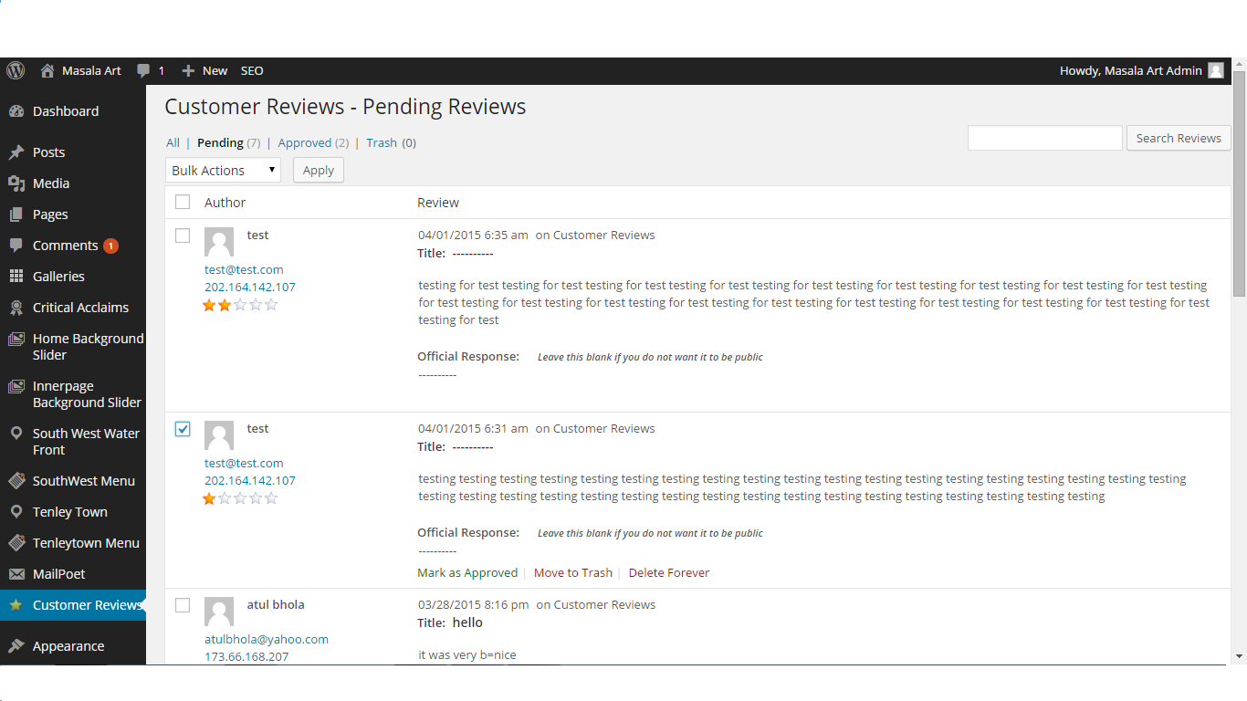
To approve an item, select the item individually and click on Mark as Approved to approve the Customer Review. To delete an item, select the item individually and click on Move To Trash to delete the Customer Review. Select the bulk actions, mentioned in the top left bar of the Customer Reviews page, in order to approve or delete more number of items together.

12. MailPoet

12.1. Newsletters
To send newsletters to the subscribers click the Newsletters menu in the fly-out menu under MailPoet, from the dashboard left navigation. You will be presented with a page similar to the image below.

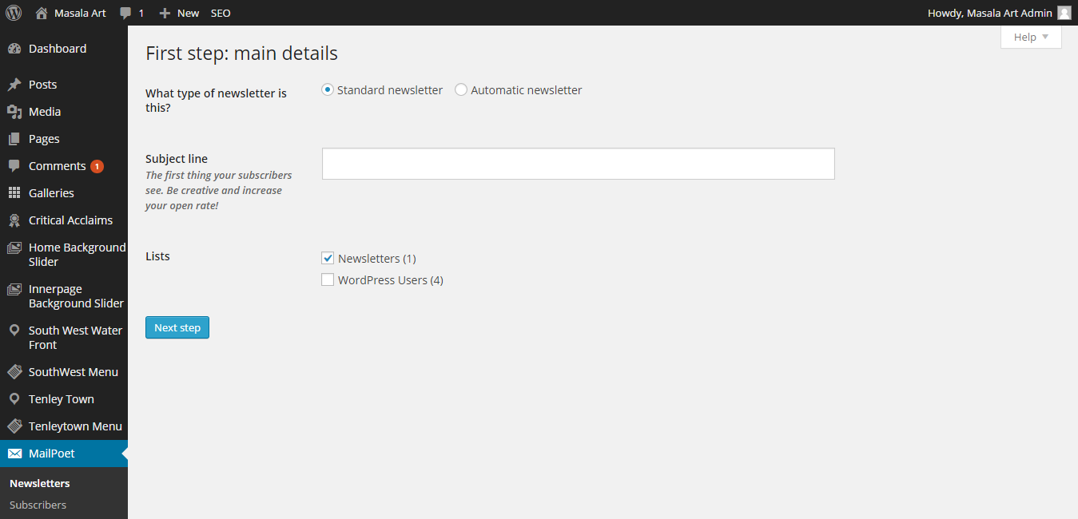

The newsletters can be sent to the subscribers with a subject line about the site.

12.2. Subscribers

To view or edit subscribers click on the Subscribers menu in the fly-out menu under MailPoet, from the dashboard left navigation. You will be presented with a page similar to the image below.

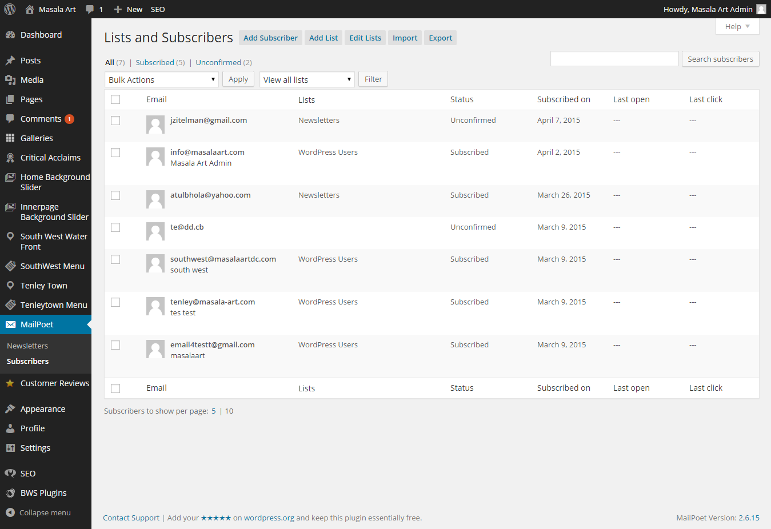

You can add subscribers, add lists, edit list, import & export subscribers by selecting the appropriate option, mentioned in the top bar of the page.

13. My Options
For managing Homepage settings such as Site logo, Copy right text , Home page banner, Home page boxes, Read more link in Home page etc. You can click on the ‘Appearance’ menu from the dashboard left navigation and in the fly-out menu, click the ‘Theme options ‘ menu Then you'll be directed to a page similar to the screenshot displayed below.

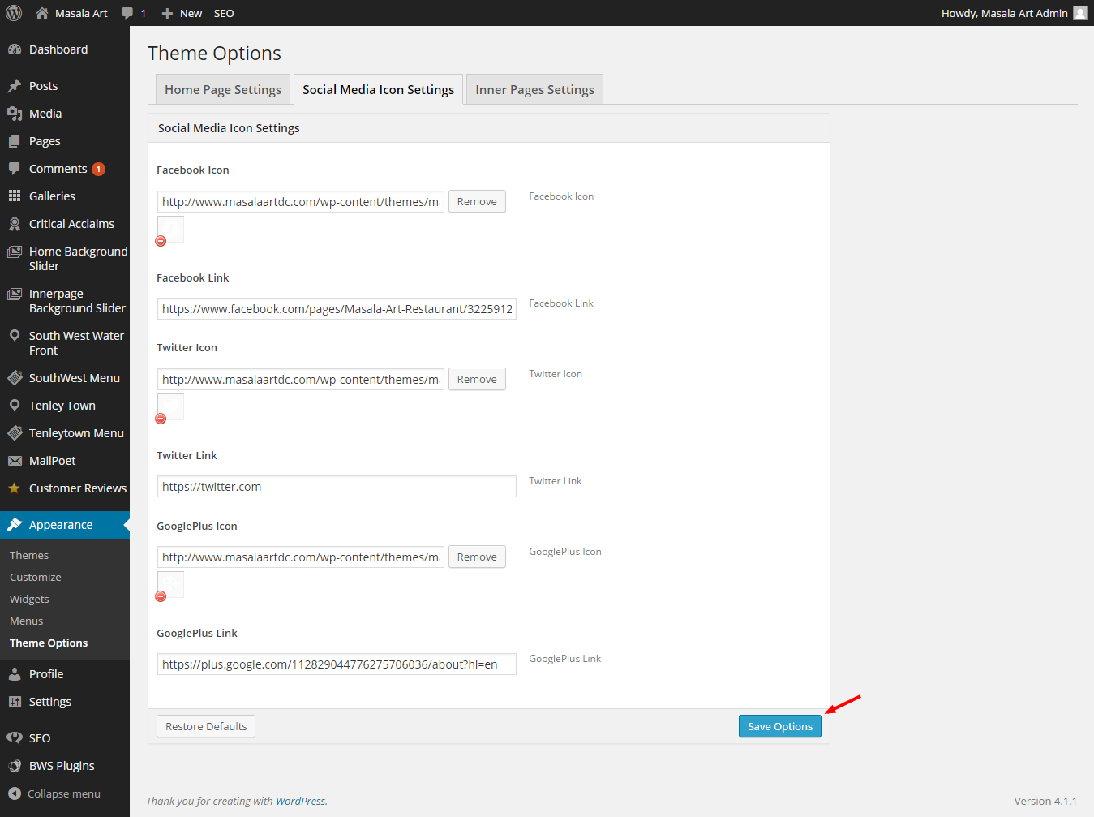

Here we have added three type of settings,
1. Home Page Settings Settings -> In home page settings, you can manage Contact Number and Email on home page top, Site Logo in home
page, Home Page images, Copy right text etc.
2. Social Media Icon settings-> In social media icon settings you can manage icons and links of social medias like facebook, twitter, google plus etc.
3. Inner Pages Settings -> In inner pages settings you can manage the inner page logo and it’s link.
Once the changes are updated, just click on the ‘Save Options’ button on right of the bottom.

